An Indicator for Sustainable Development in Indonesia:
Genuine Net Saving

Putri Irma Yuniarti
Researcher
Economic Research Center Indonesian Institute of Sciences (P2E-LIPI), Jakarta
Widya Graha LIPI Lt. 4 & 5, Jln. Gatot Subroto No. 10, Jakarta Selatan 12710

Abstract
It has been learned that there are conflicting approaches between economic development and environmental preservation. It happens because economic development focuses on how to achieve the goals of development, often by exploiting natural resources, which can lead to environmental degradation. Information around the depletion of natural resources and environmental degradation has not been included within Indonesian economic indicators yet. Apparently, Indonesia has a high rate of economic growth, shown by the increasing amount of national income. Yet, this result can come up with the exclusion of the environmental costs. In fact, environmental exploitation and natural resources extraction, results of excessive economic growth, later on will eventually cause problems and might even hamper economic development. This paper investigates these issues because they are related to one of the indicators of sustainable development, that is, Genuine Net Saving, which is the indicator of whether economic development in Indonesia meets the terms of a weak sustainability criterion. Calculating genuine net saving is carried out by reducing Indonesia’s national saving as a cost of capital from depreciation, depletion of natural resources, and the cost of environmental degradation. The results indicate that development in Indonesia does not meet the criteria of weak sustainability, which means that it is not environmentally sustainable.

Keywords: genuine net saving, green accounting, sustainable development.

Introduction
Economic indicators used today (GDP and rate of inflation) do not give information about, or take into account, natural resources depletion and environmental degradation that result from economic activity. On the other hand, sustainable development presupposes a balance of economic growth and preservation of natural resources, one of the inputs to economic activity. For example, when there is an excessive exploitation of timber stocks, there will be a decrease in the price of logged wood. As the result, the contribution of the forestry sector to GDP will also decrease because one of the products is underpriced. Not to mention the environmental problems caused by excessive logging, such as the extinction of animals and plants, floods, and a reduction in the production of oxygen, which is very important in declining the effects of global warming. These problems will cause environmental costs that might be higher than the gain from the timber exports.
Incorporating environmental variables within the calculation of national income (GDP) will definitely reduce a country’s apparent wealth. As one consequence, any new calculation method will usually be less favored by policy makers, especially because of conflicts of interests due to their various political concerns. It is always more approvable if the national wealth, indicated by the rate of economic growth, be shown to be higher. Moreover, there is no international agreement on how to estimate national income if environmental variables are to be included. It is different from the standard computation of GDP that is widely used around the world.
On the other hand, it is important to feature the cost of natural resource depletion within the calculation of national income because natural resources as high valued items cannot be separated from economic activity as factors of production. Accordingly, national income calculations that include environmental variables will be an indicator of whether the carrying capacity of the natural resources can support sustainable growth.
Some indicators for sustainable development in national accounting are recommended within System of National Accounts 2008 (SNA, 2009). They are green GDP, genuine net saving, and change in wealth per capita. There are many differences in measuring those indicators because of the limitations of data for each country. Moreover, it is not easy to integrate costs of the depreciation of natural resources and environmental degradation because there is no market price; depreciation of natural resources and environmental degradation is a problem of externalities in an economy.
In System of National Accounts 2008 (SNA, 2009), it is stated that the indicators are not included within the calculation of national income but in a satellite system that accompanies the national income calculation. There are several satellite systems described in System of National Accounts 2008, such as tourism satellite accounts, health satellite accounts, and environmental accounting, which are called the satellite systems for integrated environmental and economic accounting.
Empirical study from Pearce and Atkinson (1993) suggested that Japan, the Netherlands, the USA, and Germany, as well as Costa Rica, have met sustainability criteria (Z score > 0). The Philippines and Mexico are in a marginal condition (Z score = 0). Indonesia and Papua New Guinea belong to the group the members of which do not pass the Pearce-Atkinson sustainability test model (Z score < 0).
Empirical studies of the calculation of net saving have been published by the World Bank since 1999 in its series: World Development Indicators. Adjusted net saving is also known as genuine saving in the initial edition of the World Development Indicators, as mentioned by Hamilton and Clemens (1999). Tables 1 and 2 here show a summary of the estimated net savings for 1999 (Hamilton, 2003).

Table 1. Adjusted net savings, 1999, per cent of GDP.

Country | Gross domestic savings | Consumption of fixed capital | Energy depletion | Mineral depletion | Net forest  depletion | Carbon dioxide damage | Education expenditure | Adjusted net savings
Low income | 20.3 | 8.3 | 3.8 | 0.3 | 1.5 | 1.4 | 2.9 | 7.8
Middle income | 26.1 | 9.6 | 4.2 | 0.3 | 0.1 | 1.1 | 3.5 | 14.3
Low and middle income | 25.2 | 9.4 | 4.1 | 0.3 | 0.4 | 1.2 | 3.4 | 13.3
High income | 22.7 | 13.1 | 0.5 | 0.0 | 0.0 | 0.3 | 4.8 | 13.5
Source: World Development Indicators 2001 (Hamilton, 2003).

Table 2. Adjusted net savings, 1999, per cent of GDP.

Country | Gross domestic savings | Consumption of fixed capital | Energy depletion | Mineral depletion | Net forest depletion | Carbon dioxide damage | Education expenditure | Adjusted net savings
East Asia and Pacific | 36.1 | 9.0 | 1.3 | 0.2 | 0.4 | 1.7 | 1.7 | 25.2
Europe and Central Asia | 24.6 | 9.1 | 6.0 | 0.0 | 0.0 | 1.7 | 4.1 | 11.9
Latin America and Caribbean | 19.2 | 10.0 | 2.8 | 0.4 | 0.0 | 0.4 | 4.1 | 9.6
Middle East and North Africa | 24.2 | 9.3 | 19.7 | 0.1 | 0.0 | 1.1 | 4.7 | -1.3
South Asia | 18.3 | 8.8 | 1.0 | 0.2 | 1.8 | 1.3 | 3.1 | 8.3
Sub-Saharan Africa | 15.3 | 9.3 | 4.2 | 0.6 | 1.1 | 0.9 | 4.7 | 3.9
Source: World Development Indicators 2001 (Hamilton, 2003).

Based on the above explanation, Indonesia is categorized among those countries the economic growth of which is unsustainable. When environmental costs are included within the national income accounting, the result shows that Indonesia does not meet the sustainability criterion. Data from World Development Indicators on the contribution of natural resources to Indonesia’s economy shows that, during the period of 1970 until 2011, there has been a decline in the contribution of natural resources to Indonesia’s economy, as shown in Figure 1.

Source: World Development Indicators 2001 (Hamilton, 2003).

Figure 1. Natural resources contribution to Indonesia’s economy.

Total natural resources rents and oil rents depicted in Figure 1 are almost the same shape in graphs; this means that oil has a significant role as a natural resource commodity in Indonesian economy compared to other natural resources. The value of oil rents increased significantly over the period 1978--1980 and this is often referred to the oil boom era in Indonesia. At that time, Indonesia was an oil exporter. Since the 1980s, however, oil rents have started to decline, although in nominal terms they still give the greatest value compared to other natural resource commodities. Today, Indonesia is a net oil importer; the domestic supply of petroleum is not enough to meet domestic demand.
As well, forest rents are decreasing; they had been in decline since 1970 up to 2009 although there was a slight increase during 1997–1999. This shows that Indonesia cannot maintain the sustainability of renewable natural resources if they continue to be exploited at their current rates.
For non-renewable resources such as gas, minerals, and coal, rents have increased recently and even matched with those of petroleum. This indicates that there has been a structural change in natural resources’ contribution to Indonesian economy, which was once dominated by oil. Today, the comparative importance of other natural resource products has increased although all are non-renewable.
With the declining contribution of natural resources to Indonesia’s economy, there are two possibilities. The first is that Indonesia’s economic growth is not hampered because the initial gains from natural resources are converted to other form of capital so that Indonesia can maintain its growth with man-made capital. The second possibility is that scarcity in natural resources might be followed by a decline in national income. If made real in Indonesia, the latter possibility will be the evidence that Indonesia has been affected by the so-called resource curse. Other evidence that the resource curse has affected Indonesia is in a study conducted by Sachs and Warner (2001).

“Almost without exception, resource-abundant countries have stagnated in economic growth since the early 1970s, inspiring the term, curse of natural resources.” (Sachs and Warner, 2001).

“Empirical support for the natural resources curse is not bulletproof but is quite strong. First, casual observations suggest that there is virtually no overlap of the set of countries that have large natural resource endowments and the set of countries that have high GDP. Second, casual observation also confirms that extremely resource-abundant countries, such as the oil states of the Middle East, Nigeria, Mexico or Venezuela, have not experienced sustained rapid economic growth.” (Sachs and Warner, 2001).

The findings from repeated regressions, using growth data from post-war period, are that high intensity of resource use tends to correlate with slow growth. Sachs and Warner (1997) showed regression evidence of the curse of natural resources with as many as nine additional regressors, and Sachs and Warner (1995) showed regression evidence for the curse after controlling four popular variables favored by four other empirical growth studies. In more recent work, Sala-i-Martin (1997) and Doppelhofer et al. (2000) classified natural resources as one of the ten most robust variables in empirical studies on economic growth (Sachs and Warner, 2001).

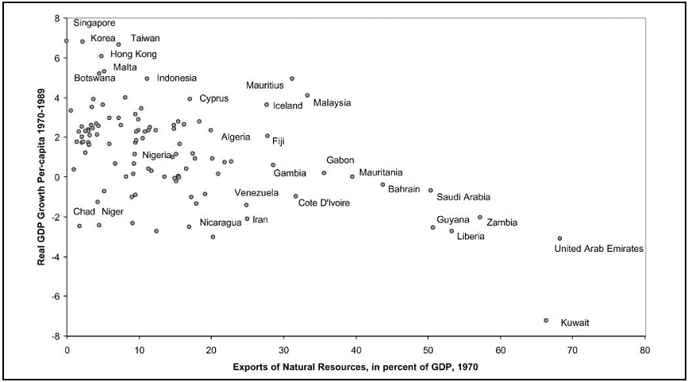
Source: Sachs and Warner (2001), p. 829.
Figure 2. Growth and natural resource abundance, 1970–1989.

Figure 2 shows that none of the countries (including Indonesia) with abundant natural resources in 1970 grew rapidly over the following 20 years (Sachs and Warner, 2001). Based on the preceding explanation, there are two questions addressed in this study. First, how much of Indonesia’s national savings from 1999 to 2007, after deducting depreciation of natural resources and the costs of environmental damage, can be called genuine net saving? Second, can Indonesian economic development be sustainable and in synergy with the environment? This study was an attempt to estimate, based on data from 1999 to 2007, the extent of genuine net saving for Indonesia, and then, based on genuine net saving calculations, determine whether Indonesia’s economic development is sustainable.

Literature review
National income is a measure of or a way of describing economic performance of a country. Economists commonly use indicators of national income (GDP) along with inflation and unemployment data in macroeconomic analysis. However, conventional GDP calculation does not take into account the production of goods that are not traded in the market and such calculations do not include the cost of pollution and environmental degradation.
Natural resources are often sold in markets and then, to some extent, are reflected in the conventional national accounts. However, the prices of the resources do not always reflect the cost of renewing such resources or the true (full) costs of the depletion of non-renewable resources. Natural assets and their services of resource supply, waste absorption and other amenities of the environment often have no price attributed to them at all, being treated as ‘free’ goods, so that their use is not fully reflected within the national accounts. The result is that in presenting the value of actual monetary transactions in the economy, the national accounts systematically understate or omit the environmental costs incurred by those transactions, that is, the costs of environmental degradation and resource depletion. GDP and related indicators thus contain a substantial element of consumption of natural capital, which is unaccounted for as a significant cost of production (United Nations, 2000).
For countries that rely heavily on natural resources extraction as a driving force for economic growth, a condition where the use of natural resources is not visible in the national economic indicators could threaten the sustainability of development.
A definition of sustainable development was formulated in the Brundtland report by the World Commission on Environment and Development (1987).

“Sustainable development is development that meets the need of the present without compromising the ability of future generations to meet their own needs.” (Tietenberg, 2003).

There were two criteria for sustainability based on Pearce and Barbier (2000) as cited in Fauzi (2004). The first is weak sustainability, which implicitly does not distinguish natural capital from man-made capital. Even though natural capital has already depleted, as long as it can be substituted by man-made capital and human capital, the aggregate value of the stock could still be improved. In other words, the maintenance or increase in total stock is enough to meet the weak sustainability criteria. In contrast, for strong sustainability, human capital and man-made capital cannot replace the assets that are primarily related to the ecological services provided by natural resources. In other words, to maintain or increase the total stock at all times requires effort to ensure that the stock of natural resources does not decline over time.
According to Salim (1991), the government can develop the concept of sustainable development by using a national income accounting system and national-regional input-output tables. Fauzi (2004) explained that in practice, measurement of weak sustainability is more common because it is the minimum requirement for testing the sustainable development of a country. There were two frequently used measurements of weak sustainability: environmentally adjusted net national product (ENP) (or green accounting or green GDP) developed by Hartwick (1990a, 1990b) and genuine net saving developed by Pearce and Atkinson (1993).
Green GDP, and the increasing use of green GDP as an indicator, has many advantages. But without using some discretion, we can create a misleading interpretation. This weakness arises because this indicator has not been consistent with the proper definition of sustainable development (non-declining welfare) and thus interpretations of this indicator for sustainable development sometimes become inaccurate (Yusuf and Alisjahbana, 2003).
Genuine net saving was introduced by Pearce and Atkinson (1993) and Pearce and Barbier (2000). Pearce and Atkinson (1993) used the size per capita for saving and output that is not decreasing over time as an indicator for sustainability, with an assumption that natural resources capital and man-made capital are perfect substitution to each other. This assumption enables the achievement of weak sustainability because although natural capital decreased the aggregate total of the capital might not decrease all the time if it can be substituted by man-made capital (Fauzi, 2004).
Fauzi (2004) explained that, mathematically, Pearce and Atkinson’s sustainability measurement could be written by:
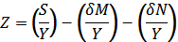 (1)

where Z is a sustainability index measured by genuine saving; S is gross domestic saving; Y is gross domestic product; δM is depreciation of man-made capital; and δN is depreciation of natural capital. Pearce and Barbier (2000) as cited in Fauzi (2004) proposed the inclusion of human capital so that:

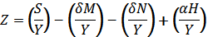 (2)
where αH is an appreciation of human resources (human capital). A positive sign before αH shows that human knowledge does not depreciate but is always growing. Hamilton et al. (1998) as cited in Fauzi (2004) included technological factors, seeing that technological change in the future would be very influential on the development of social well-being and sustainable development. Genuine saving formulation then becomes:
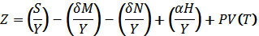 (3)

where PV(T) is present value of future technological change and PV(T) works to increase the productivity of man-made capital and thus it will increase the total stock of capital.
Intuitively, genuine net saving means investment in produced assets and human capital and less natural resource depletion and accumulation of pollutants. If the genuine net saving of a nation is positive, there is an addition to basic capital. In contrast, if the genuine net saving is negative, the development of the nation is not on the sustainable path and hence its welfare will decline. However, because our concern is welfare ‘per capita’, genuine net saving can only tell us whether total welfare per capita declined. Hamilton (2000) proposed another indicator, that is, changes in wealth per capita that takes into account population growth. Therefore, genuine net saving and wealth per capita are consistent and in accordance with the definition of sustainable development. It is therefore a more suitable indicator that can be used to measure sustainable development in Indonesia (Yusuf and Alisjahbana, 2003).
However, Neumayer (2000) as cited in Fauzi (2004) explained that differences in methods in calculating the depreciation of natural resources often lead to fundamental differences in measuring sustainability. Neumayer (2000) gave several recommendations for researchers who intend to update or create new studies of ISEW (Index of Sustainable Economic Welfare), GPI (Genuine Progress Indicator), or related measures.

“First, if one uses the resource rent method to evaluate non-renewable resources, the reference point should be national extraction of non-renewable resources, not consumption, and one should consider estimating user costs according to El Serafy (1989)’s methods instead of deducting total resource rents. Second, if one uses the replacement-cost method, the reference point should be national consumption of non-renewable resources, not extraction, and some thought should be given to whether the totality of non-renewable resources needs to be replaced in the present. More importantly, researchers in future should seriously consider abandoning the 3 per cent cost escalation factor. Third, long-term environmental damage should not be accumulated because doing so leads to multiple counting. Fourth, researchers should consider using the Pearce-Atkinson index if they want to adjust consumption expenditures for income inequality because this index demands explications of the implicit assumption about society’s aversion to inequality. Fifth, with indexing applied to any of its items, the resulting ISEW or GPI cannot be directly compared to GNP in absolute terms. Although it is tempting to do so, no such meaningful comparison is possible. Only trends over time can be compared.”

There are some studies on green accounting in Indonesia, which can be seen in Table 3.

Table 3. Studies of green accounting in Indonesia.

Research by | Study about | Period | Result
Repetto (1989) in Tietenberg (2003) | Calculation of the growth rate of Indonesia’s GNP adjusted for depreciation of natural capital (natural resources). | 1971–1984 | Without adjustment for the depreciation of natural resources, GNP grew by 7.1 per cent.  Adjusted for resource depreciation, GNP grew by 4.0 per cent per year.
Integrated Environmental and Economic Accounting (BPS) | Calculating the rate of Indonesia’s natural resources depreciation, non-renewable and renewable. | 1990–2009 | Publications and data.
Yusuf and Alisjahbana (2003) | Calculation of Indonesia’s green GDP. | 1990 and 1995 | 1990 amounted to IDR189,263,648 billion, or 89.8 per cent of GDP.  1995 amounted to IDR411,763,049 billion, or 90.6 per cent of GDP.
Alisjahbana and Yusuf (2003) | Calculating genuine net saving and change in wealth per capita. | 1980–1998 | Indonesia does not meet the criteria of weak sustainability.
Yusuf (2010) | Calculating eco-regional domestic product (ERDP) for 30 provinces in Indonesia. | 2005 | There are some provinces with susceptible economies whenever they have to meet the criteria for sustainable development. Such provinces are Papua, East Kalimantan, West Nusa Tenggara, Riau and South Sumatra.
Source: Summarized by the author from various sources..

This study will estimate genuine net savings for Indonesia for the period 1999–2007 by calculating the depreciation of natural resources, renewable and non-renewable, and also the cost of environmental degradation caused by CO₂ and NO_{x} pollution.

Methods
Estimation of genuine net saving in this study is based on the calculations by Alisjahbana and Yusuf (2003) and Yusuf (2010) with some adjustment because of the limited data.
In general, genuine net saving in this study are calculated as:

GS = S - D^{K} - D^{NR} - D^{R} - ED^{L} - ED^{G} (4)

where GS is genuine net saving; S is gross saving; D^{K} is depreciation of man-made capital; D^{R} is depreciation of non-renewable natural resources; D^{R} is depreciation of renewable natural resources; ED^{L} is local environmental degradation; and ED^{G} is global environmental degradation.

Gross saving
Gross saving is calculated by reducing GNP from consumption expenditure (C).

S = Y – C (5)
C = C^{P} + C^{G} – (C^{G}_{ED} + C^{G}_{H} ) (6)

where S is gross saving; Y is gross national product (GNP); C is consumption expenditure; C^{P} is household consumption expenditure; C^{G} is government expenditure; C^{G}_{ED} is government expenditure only for education; C^{G}_{H} is government expenditure only for health.
Unlike Alisjahbana and Yusuf (2003) who obtained data for household consumption expenditure and government spending from the Asian Development Bank, this study uses data for household consumption expenditure (C^{P}) and government spending (C^{G}) from Statistics Indonesia (BPS)‘s annual publication of Indonesia’s national income (Pendapatan Nasional Indonesia). As mentioned by Alisjahbana and Yusuf (2003), government expenditure data for health and education are from Nota Keuangan (financial memoranda) and APBN (budget papers) published by Kementerian Keuangan (the Ministry of Finance).
Alisjahbana and Yusuf (2003) also added government spending on research and development in their calculation of the adjusted consumption. However, in this study, government spending for research and development is not included within the calculation because of data limitation.

Depreciation of man-made capital
Depreciation of man-made capital is depreciation of capital accumulation that is not obtained directly from natural resources; buildings and infrastructure, for example. D^{K} is depreciation of capital or man-made capital. Data on depreciation of man-made capital in this study was obtained from Statistics Indonesia (BPS) in Pendapatan Nasional Indonesia, its serial publication of Indonesia’s national income. Depreciation of non-renewable natural resources:

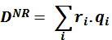 (7)

where D^{NR} is non-renewable resources depletion; i is 1,2,3, ... (types of non-renewable resources); r_{i} is unit rent from non-renewable resources i; and q_{i} is extraction quantity from non-renewable resources i.
Depreciation of non-renewable natural resources was calculated using method offered by Alisjahbana and Yusuf (2003). Because of limitation of the data, this study only used ten categories of mining products as examples of non-renewable resources. Commodities included in their calculations were crude oil, natural gas, coal, bauxite, nickel, gold, silver, iron ore, copper and tin.
Similar to Alisjahbana and Yusuf (2003), measuring the depletion of non-renewable natural resources was carried out by multiplying the quantity of extraction (qi), or changes in resource stocks, by its unit rent (r_{i}). For commodities other than iron ore and copper, this research used the extraction quantity and unit rent from the Statistics Indonesia (BPS)’s publication, Integrated Environmental and Economic Accounting, 1990--2007. However, iron ore and copper had not counted in this publication and therefore, for iron and copper ore, this study used the methods of Alisjahbana and Yusuf (2003).
Alisjahbana and Yusuf (2003) calculated the weighted average price for each resource because the resources extracted sold in various markets, domestic and international, that command different prices. On the other hand, World Bank estimations use the international price only and ignore the specific conditions of the country. Alisjahbana and Yusuf (2003) follow Hamilton (1998) to obtain unit rents by multiplying the price of commodities by a constant, 0.58 for iron ore and 0.49 for copper.
This study followed Hamilton et al. (1998), as cited in Alisjahbana and Yusuf (2003), to calculate the unit rent for iron ore and copper. However, this paper used domestic iron ore prices because export prices were not available in time series data. Nevertheless, on the regard of the price of copper, we used only the export price because transactions in domestic prices were not available in time-series data. Data for iron ore and copper extraction (qi) were obtained from mining statistics, published annually by Statistics Indonesia (BPS). After that, producing an annual series of cost depletion would be conducted by multiplying the rent by depletion volume for each resource. Depreciation of renewable natural resources was formulated as follows:

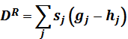 (8)
where D^{R} is renewable resources depletion; j is 1,2,3, ... (types of renewable resources); s_{j} is unit rent from renewable resources j; g_{j} is the final quantity from renewable resources j; and h_{j} is the initial quantity from renewable resources j.
Because of the limitation of the current data and methods, this study calculated depreciation of renewable natural resources for the forestry sector only, that is, round wood, as has been carried out by Alisjahbana and Yusuf (2003). For the reason that it included one type of resource only, this net depletion was called ‘excess felling’. Excess felling was defined as the volume of round wood production in excess of natural growth (Alisjahbana and Yusuf , 2003).
This study followed Alisjahbana and Yusuf (2003) in calculating the unit rent of round wood. It used an average price of world exports (calculated from the FAOSTAT database) to estimate the unit rent from round wood. Based on studies by the Indonesia-UK Tropical Forest Management Programme (ITFMP, 1999) (cited in Alisjahbana and Yusuf, 2003), the unit rent of round wood was estimated to be 72.41 per cent of the price. Then the unit rent of round wood was calculated as a percentage of the average export price for each year.
Alisjahbana and Yusuf (2003) used industrial round wood data from the (United Nations) Food and Agriculture Organization to estimate the quantity of round wood extraction in the forestry sector. Then the extraction quantity was reduced by the amount of growth or natural growth. To calculate the magnitude of the natural growth of round wood, Alisjahbana and Yusuf (2003) used forest wood growth data from Integrated Environmental and Economic Accounting, 1999–2007, published by Statistics Indonesia (BPS).
Unlike the abovementioned methods, to estimate the quantity of round wood extracted, this study used data from Integrated Environmental and Economic Accounting, 1999–2007, which provides statistics of the initial and final quantities of timber in Indonesia’s forests. Data of forest wood quantity in BPS publications are explained in a physical balance by the following equation:

Final stock of timber = Initial stock + Natural growth + New plantation - Logging - Conversion and damage (9)

From equation 9, the depletion of forest wood in Indonesia can be calculated. After that, it is multiplied by the amount of unit rent to estimate the depletion of forest resources.

Local environmental degradation

ED^{L} = NO_{x} . ved (10)

where ED^{L} is environmental degradation from local pollution; NO_{x} is the volume of nitrogen oxide emissions from motor vehicles; and ved is value of external damage.
Alisjahbana and Yusuf (2003) calculated the damage caused by industrial sectors to estimate environmental damage from local pollution. However, this study did not use Alisjahbana and Yusuf’s (2003) methods because of limitation of data. Instead, this study used Yusuf’s (2010) method to calculate the environmental damage caused by the transport sector.
Yusuf (2010) explained that because of the availability of data (on emissions) and the availability of a reference to calculate the value (unit) of environmental degradation, he put local pollution from motor vehicle emissions in the form of nitrogen oxides (NO_{x}). The source of data on NO_{x} emissions was Indonesian environment statistics, published by Statistics Indonesia (BPS).
Assessment was carried out by multiplying NO_{x} emissions (in tons per year) by the value of external damage per ton of emissions. The value of damage for several countries in Europe was obtained from the European Commission as compiled by AEA Technology (AEA, 2007). For this study, the value of external damage was calculated for several countries in Europe. For this analysis, Yusuf (2010) chose the value calculated of Latvia because of its similarity to Indonesia in terms of GDP per capita. Based on these studies, it was found that the damage per ton of NO_{x} emissions per year was EUR 3366 in 2000. However Yusuf (2010) estimated that it was in 2005 only. Therefore, to estimate the damage caused by emissions of NO_{x} for other years, the damage per ton of NO_{x} emissions per year should be adjusted by the exchange rate between the relevant Euro and the USD, and by the consumer price index.

Global environmental degradation

(11)

where ED^{G} is environmental degradation from global pollution; mc is marginal cost from CO₂; and CO₂ is the volume of CO₂ emissions.
This study used Alisjahbana and Yusuf’s (2003) methods to calculate the value of environmental degradation from ‘global type’ emissions, carbon dioxide (CO₂). Alisjahbana and Yusuf (2003) followed the methodology used in the World Bank study of Hamilton and Clemens (1999) to quantify global damage costs of CO₂ emissions. It was assumed that the global damage from pollution was charged to those countries that caused the pollution, and it was assumed also that ensuring the property right to a clean environment was a matter that lied with the emitters. Indonesia’s annual CO₂ emissions data were obtained from the World Bank’s World Development Indicators.
Marginal cost per metric ton of CO₂ was assumed to be USD 20 in 1990 (the cost of which was also applied for the estimation of the adjusted saving by Hamilton and Clemens (1999), published in World Bank’s publication. Marginal cost was estimated on an annual basis using the exchange rate between the USD and IDR and also the wholesale price index for 1999–2007.

Unit rent
According to Suparmoko (2008), unit rent was the price of natural resources for the resources that still exist in nature, and was called the standing value in case of forest resources. Generally, the data for unit rent are not available but it can be calculated using the following equation:

Ri = Hi - Bi - Li (12)

where Ri is unit rent for a commodity i; Hi is the price for the commodity i; Bi is total costs for all commodities i (raw materials, wages, rent, interest rate); Li is profit form the commodity i; and i is a commodity, for example, rattan.
Unit rent is crucial in the calculation of genuine net saving, because when the unit rent is multiplied by the quantity of extraction it will determine the value of genuine net saving. When unit rent is small, it will increase the genuine net saving. On the other hand, when the unit rent is large, it will reduce the value of genuine net saving.

Limitations of this study
Results of genuine net saving calculations varied because there was no standardized method yet for calculating genuine net saving. Therefore, the span of counted natural resources and the calculation methods depended on the researcher and the availability of data.
The study considered only timber for calculating the depletion of renewable natural resources. Furthermore, for environmental degradation caused by pollution at the local level, this study only considered pollution by the nitrogen oxides (NO_{x}) that are produced by the transport sector. This study hence did not incorporate pollution from industrial and household sectors. For global pollution, this study only incorporated air pollution in the form of carbon dioxide (CO₂) and did not include other atmospheric pollutants, such as SO₂ and NO₂, from vehicle exhaust emissions. Neither soil pollution nor water pollution were included in the calculations yet. Therefore, the amount of genuine net saving here might be understated.
This study had not taken into account new discoveries of natural resources in Indonesia, i.e. resources that can increase the value of genuine net saving. Because of data limitation, it did not incorporate expenditure on research and development, which should be added as a saving (investment).

Data analysis
For the period of 1999–2007, Indonesia’s conventional savings showed a trend to increase. Moreover, if government spending on health and education was considered as investment, then Indonesia’s savings were higher. However, when savings were reduced by the cost of resource depletion and environmental degradation then the result turns out to be negative. Therefore, the genuine net saving for Indonesia from 1999 to 2007 was negative and was continuing to decline.
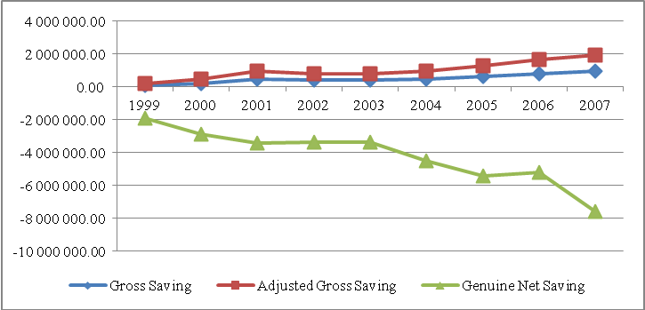
Source: Author’s calculation.
Figure 3. Gross saving, adjusted gross saving, and genuine saving of Indonesia,
from 1999 to 2007 (in IDR billion).

The decline of genuine net saving was in line with the increasing depletion of natural resources, especially forestry and minerals, as shown in Figure 4.

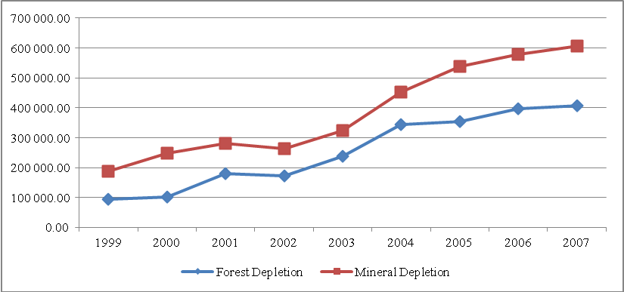
Source: Author’s calculation.
Figure 4. Depletion of natural resources in Indonesia (IDR billion).

The most significant decrease in the genuine net saving curve was in 2006–2007. Genuine net saving calculation showed that the upward slope of the curve decreased rapidly because of the increasing value of local environmental degradation from IDR 8,719.69 billion only in 2006 to IDR 13,711.10 billion in 2007. Local environmental degradation figures in this study were obtained by the multiplication of the volume of nitrogen oxidant emissions from motor vehicles and the value of external damage (ED^{L} = NO_{x} . ved). Therefore, the increase in local environmental degradation was most probably caused by the growing number of motor vehicles in Indonesia, which was followed by the rise in NO_{x} emissions from motor vehicles.

Table 4. Growth of motor vehicles by type.

Year | Passenger cars | Buses | Trucks | Motorcycles | Total
2003 | 3,792,510 | 798,079 | 2,047,022 | 19,976,376 | 26,613,987
2004 | 4,231,901 | 933,251 | 2,315,781 | 23,061,021 | 30,541,954
2005 | 5,076,230 | 1,110,255 | 2,875,116 | 28,531,831 | 37,623,432
2006 | 6,035,291 | 1,350,047 | 3,398,956 | 32,528,758 | 43,313,052
2007 | 6,877,229 | 1,736,087 | 4,234,236 | 41,955,128 | 54,802,680
Source: Indonesian National Police.

The cost of environmental degradation from pollution with global effects was higher than the cost of pollution with local effects. It was also larger compared to the cost due to depreciation of natural resources (depletion). This high value (IDR 9,750,017.80 billion in 2007) might be ascribed to the large emissions of CO₂, and perhaps also to the changes in exchange rates used to adjust the costs of CO₂ emissions from the USD to the EUR. Likewise, the cost of damage from NO_{x} was less than the cost of damage from CO₂. In 1999, the amount was merely IDR 2,948.31 billion, compared to the damage caused by CO₂ emissions in the same year that amounted to IDR 1,984,615.07 billion.

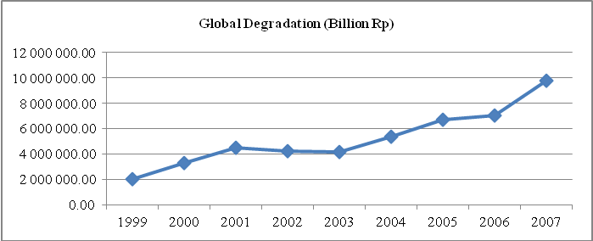
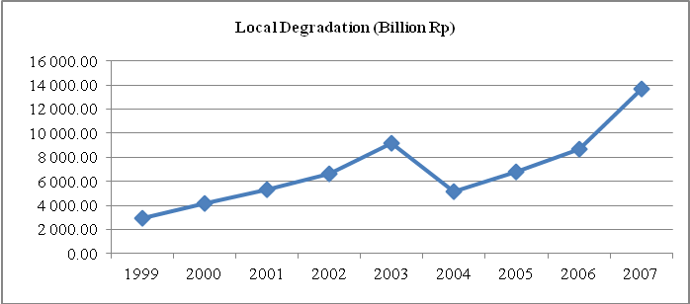
Source: Author’s calculation.
Figure 5. Environmental degradation.

Calculations of genuine net saving for Indonesia from 1999 to 2007 showed a consistent negative trend. This graph indicated that economic development in Indonesia was very reliant on the extraction of natural resources (see Figure 6). It was concluded that Indonesia had not met the criteria for sustainability. Nominally, over the period 1999 to 2007, there had been only one increase in the genuine net saving rate, from IDR -4,379,154.41 billion in 2001 to IDR -4,179,138.04 billion in 2002. However, in other years, the nominal amount of genuine net savings continued to decline (persistently negative). In 2007, there was a sharp decline and the value of genuine net saving fell to IDR -9,552,142.07 billion.

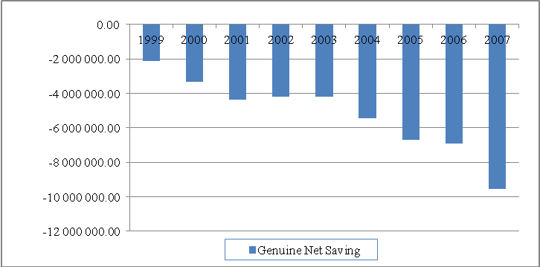
Source: Author’s calculation.

Figure 6. Genuine net saving of Indonesia, 1999–2007 (USD billion).

The results were consistent with several previous studies of genuine net saving in Indonesia, although the magnitudes of the numbers were different because the methods and data used were also different. They indicated the same thing, that development in Indonesia did not meet environmental criteria for sustainability.
In fact, most countries with considerable natural resources endowment, such as Indonesia and African countries, had a negative rate of genuine net saving. This was possible because of their dependence on extraction of natural resources without giving value added. In the market, their products were underpriced. As a result, the resources did not provide enough revenue for the country to raise its level of income and welfare.
From the genuine net saving calculation, GS = S - D^{K} - D^{NR} - D^{R} - ED^{L} - ED^{G}, Lee (2010) suggests several ways to increase GS.

1. Make S bigger and keep other variables constant or keep them at present levels.
2. Make S bigger while keeping the increase in other components less than the increase in S.
3. Make S bigger and others smaller.
4. Make others smaller while keeping S unchanged.
5. Make others smaller and keep the decrease in S to less than the decrease in others.

In the context of Indonesia, it was possible to increase S by increasing the number of national products and output. It was also possible to increase investment, whether capital or human resources investment, through education and also research and development. However, increasing output would surely also increase pollution and environmental degradation. Therefore, what was possible in Indonesia to increase GS was by making S bigger and keeping the increase in other components less than the increase in S.
There were other policies that can be implemented in Indonesia. One was to set taxes and subsidies for goods produced from natural resources. Taxes and subsidies can be used to set the correct price. Because pollution is an externality, it is necessary that the government levy taxes on organizations or industries that cause pollution. The government should reduce fuel subsidies or even eliminate them because such subsidies increase the use of fuels and consequently increase pollution and lead to a waste of resources. The prices for goods produced from natural resources, that is, for example, from agriculture, plantation and mining, must be set in such a way that they are not underpriced. The following SWOT analysis shows how Indonesia can obtain much higher genuine net saving.

Strengths  - Indonesia has a huge natural endowment and a large population. If used appropriately, Indonesia can maintain a high growth and a sustainable economy. | Weaknesses  - There is a lack of capital and technology in Indonesia. This creates dependence on foreign capital and technology. Consequently, there is too much foreign intervention in the utilisation of natural resources, especially mining commodities.  - Indonesia has a large population, however, with low education and skills.  - There is minimum value added for natural resource products, therefore the products are underpriced.
Opportunities  - Discourse on green growth and sustainable development can improve the system only if this discourse can be realised.  - There are big markets in Indonesia and abroad for Indonesia’s increasing production. | Threats  - Economic growth and industrialisation will create pollution.  - Unsustainable exploitation and utilisation of natural resources can endanger the survival of future generations.  - Population growth will require large space for housing and agriculture. It will increase forest clearing and increase environmental degradation.

In the context of decentralization, green accounting could also be implemented through the calculation of pendapatan domestik regional bruto or green regional gross domestic product (RGDP) in each province. Yusuf (2010) had estimated green or eco-regional domestic product of Indonesian provinces for the year 2005. Yusuf (2010) found that Papua, East Kalimantan, West Nusa Tenggara, Riau and South Sumatra were vulnerable provinces in terms of sustainable development, because their income had been very dependent on natural resources extraction.
Yusuf (2010) also found that environmental degradation in Indonesia was concentrated in the provinces that had highly active manufacturing sectors and large populations. The highest was the capital city, Jakarta, with a nominal value of environmental damage caused by pollution of IDR 18 trillion. Jakarta was followed by East Java province with a nominal value of environmental damage of IDR 16 trillion and Central Java province with IDR 12 trillion. However, the cost of environmental damage and degradation, considered as a percentage of GDP, was highest in the provinces such as Bali, Yogyakarta, Maluku, South Sulawesi and West Sumatra because they had intensive energy consumption and a high number of motor vehicles. Nominally, Jakarta, East Java and Central Java had high value for environmental damage, but the economic output (GDP) was high enough, so relatively, the environmental degradation was less than for Bali, Yogyakarta, Maluku, South Sulawesi and West Sumatra.

Conclusion
There is much to do to improve genuine net saving as an indicator because the collecting the data and the methods are still difficult. For example, in valuing the damage from pollution and environmental degradation, better method of calculation is needed, but the skill and knowledge to do this are not easy to come by in the realm of economics.
If environmental costs are included in the measurement and calculation of genuine net saving from 1999 to 2007 and the result is negative, the costs are greater than the income. It shows that growth in the past few years has sacrificed the environment. The development in Indonesia does not meet the weak sustainability criteria or, of course, the strong sustainability criteria.

Recommendation for future studies
In this study, calculation of the depletion of renewable resources only included timber from forest resources. Future studies should count losses from other forms of forest exploitation, including intangible assets, such as forest absorption of carbon dioxide, water absorption and flood control, as well as a shelter for wild life. Variables can also be added from other renewable assets such as fish and marine products. In the calculation of environmental degradation, variables can be added for forms of pollution other than CO₂ and NO_{x}.

References

AEA. (2007). Assessing how the costs and benefits of environmental policy change over time: final report. Brussels: European Commission.

Alisjahbana, Armida and Arief Anshory Yusuf. (2003). Assessing Indonesia’s sustainable development: long-run trend, impact of the crisis, and adjustment during the recovery period. Working Paper in Economics and Development Studies 200306. Bandung: Padjadjaran University.
Badan Pusat Statistik. Pendapatan nasional Indonesia [Indonesian national income], Jakarta: Badan Pusat Statistik. (Various years).

Badan Pusat Statistik. Perkembangan jumlah kendaraan bermotor menurut jenis, tahun 1987–2011. Jakarta: Badan Pusat Statistik. http://www.bps.go.id/tab_sub/view.php?tabel=1&daftar=1&id_subyek=17&notab=12

Badan Pusat Statistik. Sistem terintegrasi neraca lingkungan dan ekonomi Indonesia 2007---2011. Jakarta: Badan Pusat Statistik. (Various years).

Badan Pusat Statistik. Statistik lingkungan hidup Indonesia, Jakarta: Badan Pusat Statistik. (Various years).

Badan Pusat Statistik. Statistik pertambangan minyak dan gas bumi [Mining statistics of petroleum and natural gas of Indonesia]. Jakarta: Badan Pusat Statistik. Various issues. (Various years).

Badan Pusat Statistik, Statistik pertambangan non minyak dan gas bumi, 2006–2010, Jakarta, Indonesia. (Various years).

Departemen Kehutanan. (2009). Perhitungan deforestasi Indonesia 2008. Jakarta: Departemen Kehutanan [Department of Forestry].

Doppelhofer, G, RI Miller and X Sala-i-Martin. (2000). Determinants of long-term growth: a Bayesian averaging of classical assessments (BACE) approach. Working Paper 7750. Cambridge: National Bureau of Economic Research.

El Serafy, S, (1989). The proper calculation of income from depletable natural resources. In Ahmad. Y.J., El Serafy and E. Lutz. Environmental accounting for Sustainable Development. The World Bank. Washington DC.

Fauzi, Akhmad. (2004). Ekonomi sumber daya alam dan lingkungan, teori dan aplikasi. Jakarta: PT Gramedia Pustaka Utama.

Hartwick, John M. 1990(a). Natural resources, national accounting and economic depreciation. Journal of Public Economics. Elsevier. Vol. 43(3). Pages: 291-304. North Holland.

Hartwick, John M. 1990(b). Pollution and national accounting. Working papers 772. Queen’s University. Department of Economics.

Hamilton, Kirk. (2000, August). Sustaining economic welfare: estimating changes in wealth per capita. In Paper for the General Conference of the IARIW, Poland.
(URL: http://iariw.org/papers/2000/hamilton.PDF)

Hamilton, Kirk. (2003). Accounting for sustainability. Washington: World Bank. (URL: http://www.oecd.org/dataoecd/18/53/2713847.doc)

Hamilton, K., Atkinson, G., & Pearce, D. (1998, June). Savings rules and sustainability: selected extensions. In 1st World Congress of Environmental and Resource Economists, Venice, Italy, June.
Hamilton, K and M Clemens. (1999). Genuine saving rates in developing countries. World Bank economic review, 13: 353–356.

ITFMP. (1999). Illegal logging in Indonesia. Report no. PFM/EC/99/03. Jakarta: Indonesia–U.K. Tropical Forest Management Programme.

KESDM. (2008). Key indicator of Indonesia energy and mineral resources. Jakarta: Kementrian Energi dan Sumber Daya Mineral [Ministry of Energy and Mineral Resources].

KESDM. (2009). Handbook of energy and economic statistics of Indonesia. Jakarta: Kementrian Energi dan Sumber Daya Mineral [Ministry of Energy and Mineral Resources].

Lee, J. (2010). Green growth: Korean initiatives for green civilization. Seoul: Random House Korea.

Neumayer, Eric. (2000). Analysis on the methodology of ISEW, GPI and related measures: some constructive suggestions and some doubt on the “threshold” hypothesis. Ecological economics, 34: 347–361. (URL: www.elsevier.com/locate/ecolecon).

Pearce, DW and G Atkinson. (1993). Capital theory and the measurement of sustainable development: an indicator of weak sustainability. Ecological economics, 8: 103–108.

Pearce, DW and Edward B. Barbier. (2000). Blueprint for a Sustainable Economy. Earthscan publications. London.

Sachs, JD and AM Warner. (1997). Sources of slow growth in African economies. Journal of African economies, 6(3): 335–376.

Sachs, Jeffrey D and Andrew M Warner. (2001). The curse of natural resources. European economic review, 45: 827–838. (URL: www.elsevier.com/locate/econbase).

Sala-i-Martin, X. (1997). I just ran two million regressions. American economic review, 87(2): 178–183.

Salim, Emil. (1991). Pembangunan berkelanjutan: strategi alternatif dalam pembangunan dekade sembilan puluhan. Majalah prisma, XX(1).

Suparmoko, M. (2008). Kontribusi sektor kehutanan pada pembangunan daerah kabupaten Blora. Jurnal ekonomi pembangunan, kajian ekonomi negara berkembang, 13(3): 217–229.

SNA. (2009). System of national accounts 2008. New York: European Commission, International Monetary Fund, Organisation for Economic Co-operation and Development, United Nations and World Bank.

Tietenberg, Tom. (2003). Environmental and natural resource economics. Sixth edn. Boston: Addison-Wesley.

United Nations. (1987). Our Common future, Report of the World Commission on Environment and Development. (URL: http://conspect.nl/pdf/Our_Common_Future-Brundtland_Report_1987.pdf)

United Nations. (2000). Handbook of national accounting: integrated environmental and economic accounting: an operational manual. New York: United Nations.

Yusuf, Arief Anshori. (2010). Estimates of the ‘green’ or ‘eco’ regional domestic product of Indonesian provinces for the year 2005. Working Paper in Economics and Development Studies 201004. Bandung: Padjadjaran University.

Yusuf, Arief Anshori and Armida S Alisjahbana. (2003). To what extent green accounting measure sustainable development. Working paper in economics and development studies 2030307. Bandung: Padjadjaran University.

World Bank. (various years). World development indicators. Washington: World Bank. (URL: http://data.worldbank.org/data-catalog/world-development-indicators).

This paper is based on Putri Irma Yuniarti’s master thesis (accepted in 2011) and was presented at the 12th Sciences Council of Asia Conference and International Symposium, 10–12 July 2012, Bogor, Indonesia and published in the proceedings of the seminar. Thanks to Professor Mangara Tambunan, the thesis supervisor, for suggesting the research topic.
The FAOSTAT database can be found at this URL: http://faostat.fao.org
This URL will lead you to the National Police database: http://www.bps.go.id/tab_sub/view.php?tabel=1&daftar=1&id_subyek=17&notab=12.

